CSC 271 Data Structures
Lab 2: Pointers in C++

- Consider next typical C++ program. Compare its structure with a Java program structure. Compile and execute the programs in personImp.zip.
- Design and implement a C++ program, that prints on the screen the size of different primitive data types in C++. Design a simple class without any data and methods and create an object of this class. Print out the size of the object.

- Write a program that will read ten integers from the keyboard and place them in an array. The program then will sort the array into ascending and descending order and print the sorted list. The program must not change the original array or create any other integer arrays.
The solution to this problem requires two pointer arrays, as shown in the figure below. The first pointer array is rearranged so that it points to the data in ascending sequence. The second array is rearranged to that it points to the data in descending sequence.

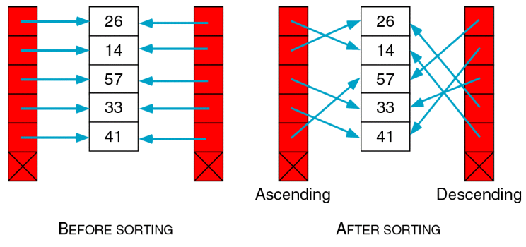

Your output should be formatted with the three arrays printed as a vertical list next to each other, as shown in the next table.

Ascending | Original | Descending
14 | 26 | 57
26 | 14 | 41
33 | 57 | 33
41 | 33 | 26
57 | 41 | 14

Demonstrate your solution to the instructor.
Handle a hardcopy of your code.

